CV: Blake Guyan

Email: Blake_guyan@hotmail.com Phone: 0208-933-1542

To view this CV as it was intended visit: Blakeart.co.uk

Blake is a Treehouse student.
Go to:
https://teamtreehouse.com/blakeguyan
To see my courses and awards

News On The Block
“Blake is never put off by a challenge, when we asked for a feature or a design he would always find a way of making it work or creating a solution to the problem. Blake is also very dedicated, if there were a deadline for a project he would make sure that the work was
ready for when we needed it.”
Anistasia Morton

Freelance Designer/Developer

News On The Block September 2016- April 2017

Key Achievements: Designed and coded visually diverse pages for a range of events on a tight schedule.
Created bright and lively print and digital media for display at a number of events at venues including Wembley Stadium and County Hall London.

Created and managed Email marketing via the .mailer marketing platform managing the design and delivery of thousands of emails a week.

Freelance 3D Artist

Artistocrats
November 2015 - April 2017

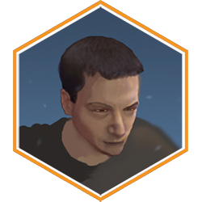
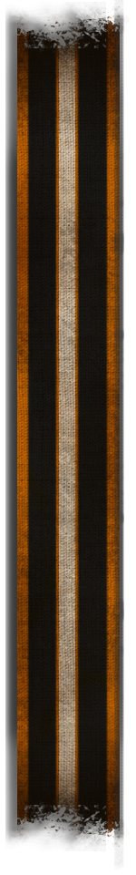
Key Achievements: Created end turn animations so striking that the company I worked for paid me to build similar ones for their other games.

Creating a range of models and textures that had to be both very polygon efficient as well as being recognizably different from others at a glance, sometimes by silhouette alone

CV: Blake Guyan

Email: Blake_guyan@hotmail.com Phone: 0208-933-1542

Freelance Digital Sculptor

FBFX
January 2015 - July 2015

Key Achievements: Created truly photorealistic 3D sculpts and textures using photogrammetry, people are still shocked when I tell them that they are not real.

Working with truly innovative procedures and software to push the boundaries of current photorealistic 3D modelling.

Freelance 3D Artist

The Motion Box April 2014

Key Achievements: Within the timeframe of 4 weeks I took 7 high resolution models of men, women and children reduced the polycount to under a thousand and created a crowd of thousands of unique spectators complete with animations and interchangeable body parts.

Created a system of PSD documents and 3D meshes that could be used to quickly generate a large number of randomised characters for future crowd simulations.

Freelance 3D Artist

Sky Television
March 2013 - September 2014

Key Achievements: Created such an impressive render on day one that I was invited back to help completely re-build the art style for sky sports that they still use to this day!

Often poached by other projects within the department as a consultant on texturing and modelling

About Blake:
I often refer to myself as a “Freelance nerd” mostly because it is so hard to pin down what it is exactly that I do.

I am passionate about creating things that really make people wonder “how did they do that” or that simply look fantastic. The most common feedback I get from people I work with is that they are glad I am so communicative about the design process, while I am happy working from start to finish alone I tend to work on the premise that the design is as much the brainchild
of the client as me, which I find tends to create a design closer to the clients own vision than something more impersonal.
Working in front end development is the perfect field for me, it allows me to indulge my creative side with layout and design while allowing my technical side to solve the innumerable questions posed by creating interesting and dynamic pages.

